Task on monitoring

- Enable cloudtrail monitoring and store the events in s3 and cloudwatch log events.

Go to aws console
Search for cloudtrail and click on create a trail
Then fill all the details as mentioned in the below document .

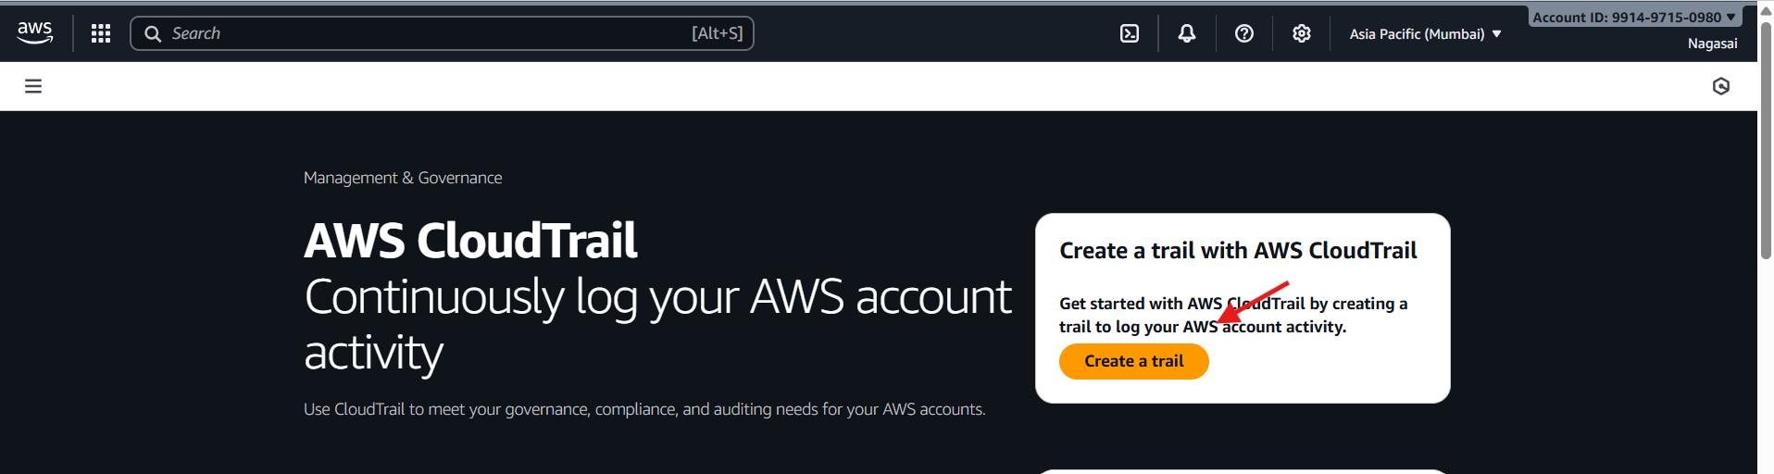
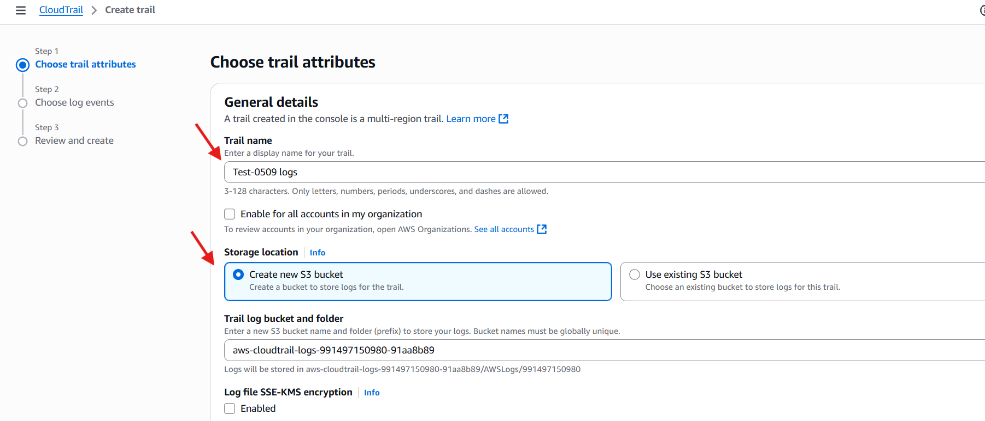
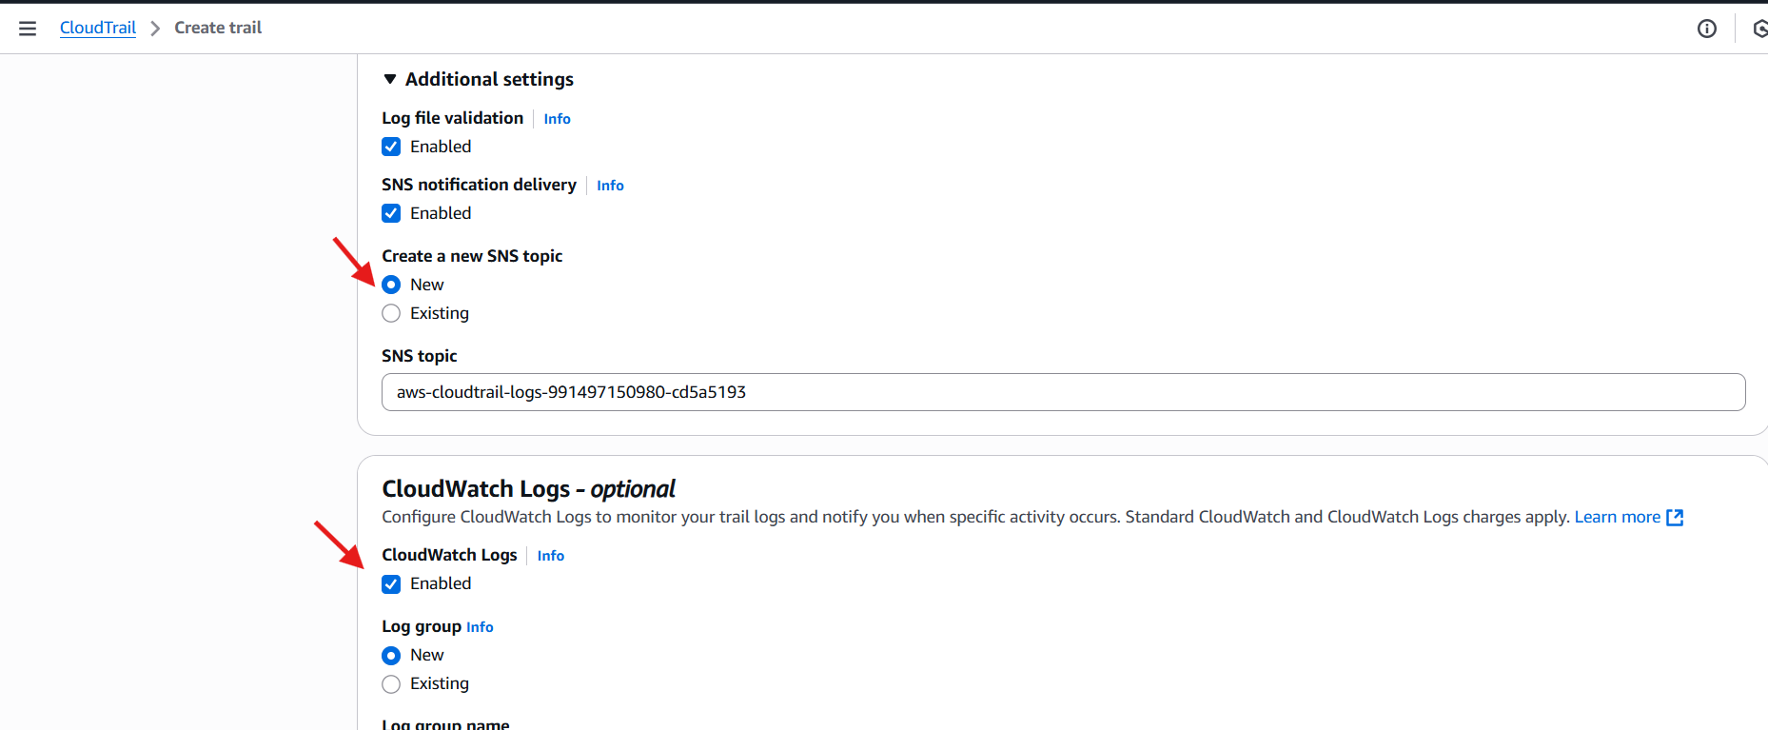
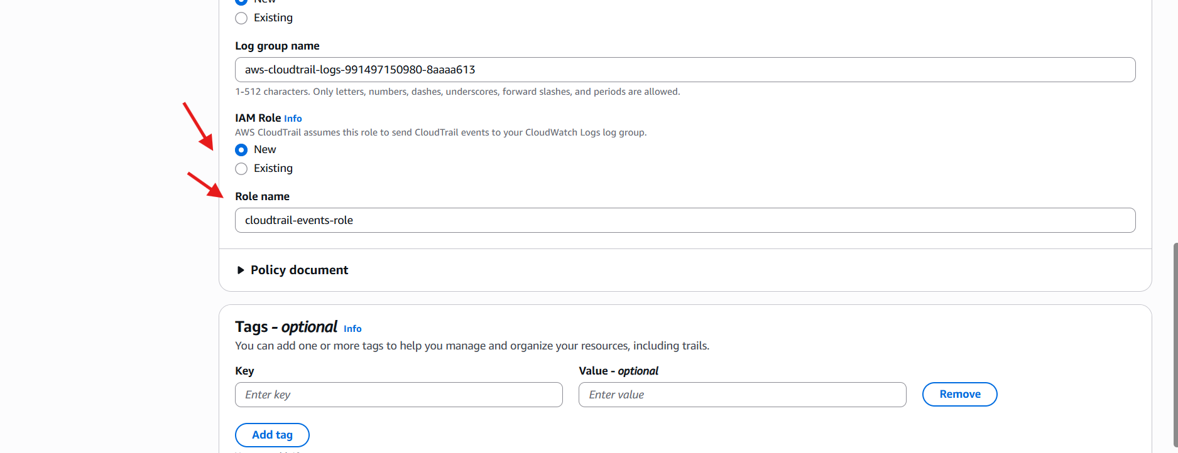
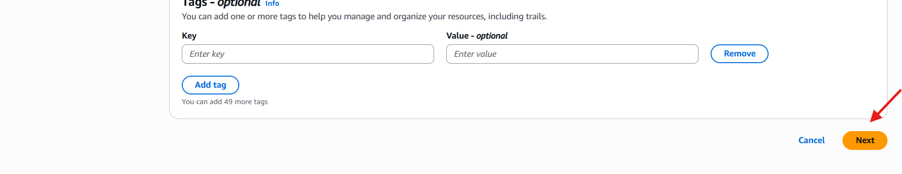
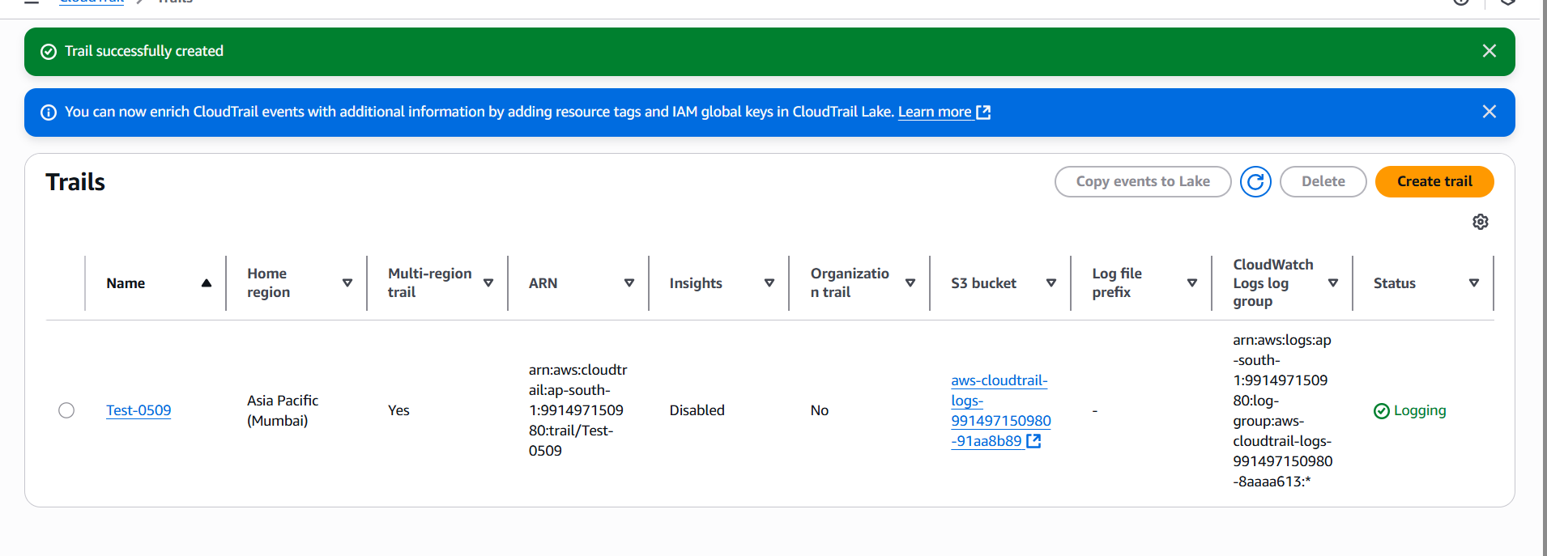
And finally we can see the events in loggroups.
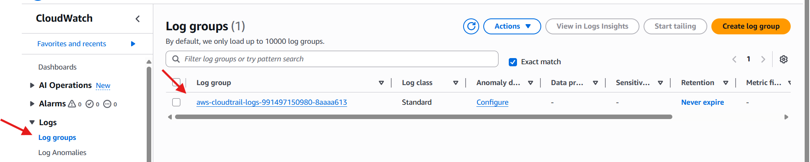

- Enable SNS for cloudtrial to send alert on email.
Go to aws console
Click on sns service
In sns first we have to create a topic for that give the topic name and create topic.
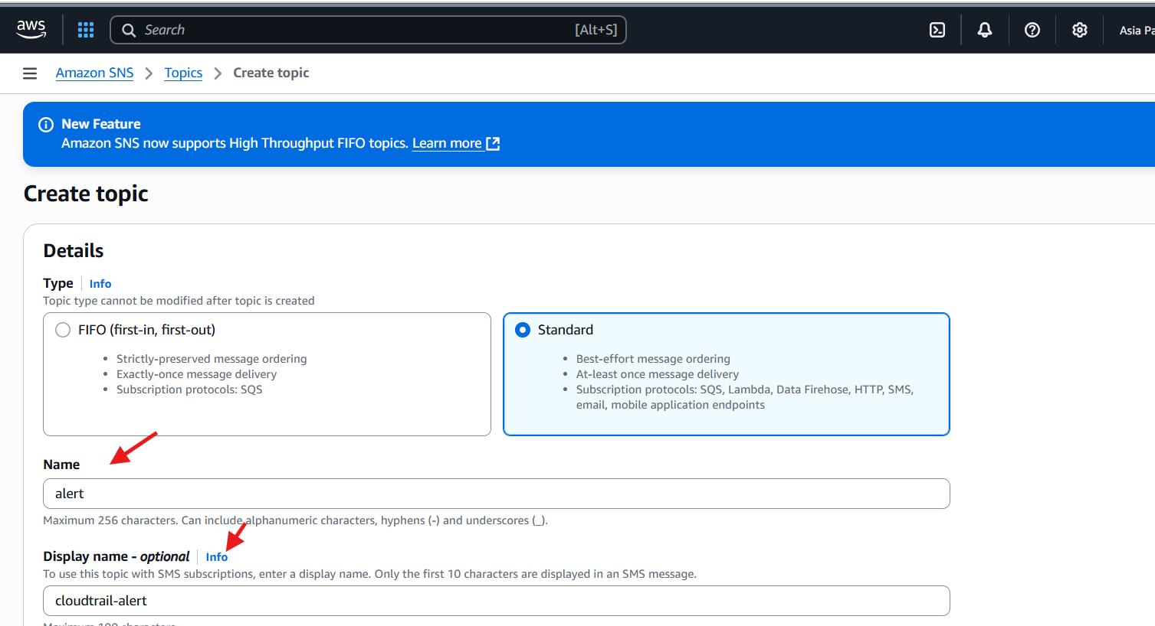
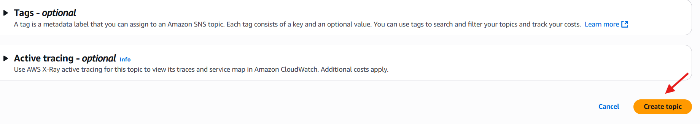
After topic is created we have to create a subscription.
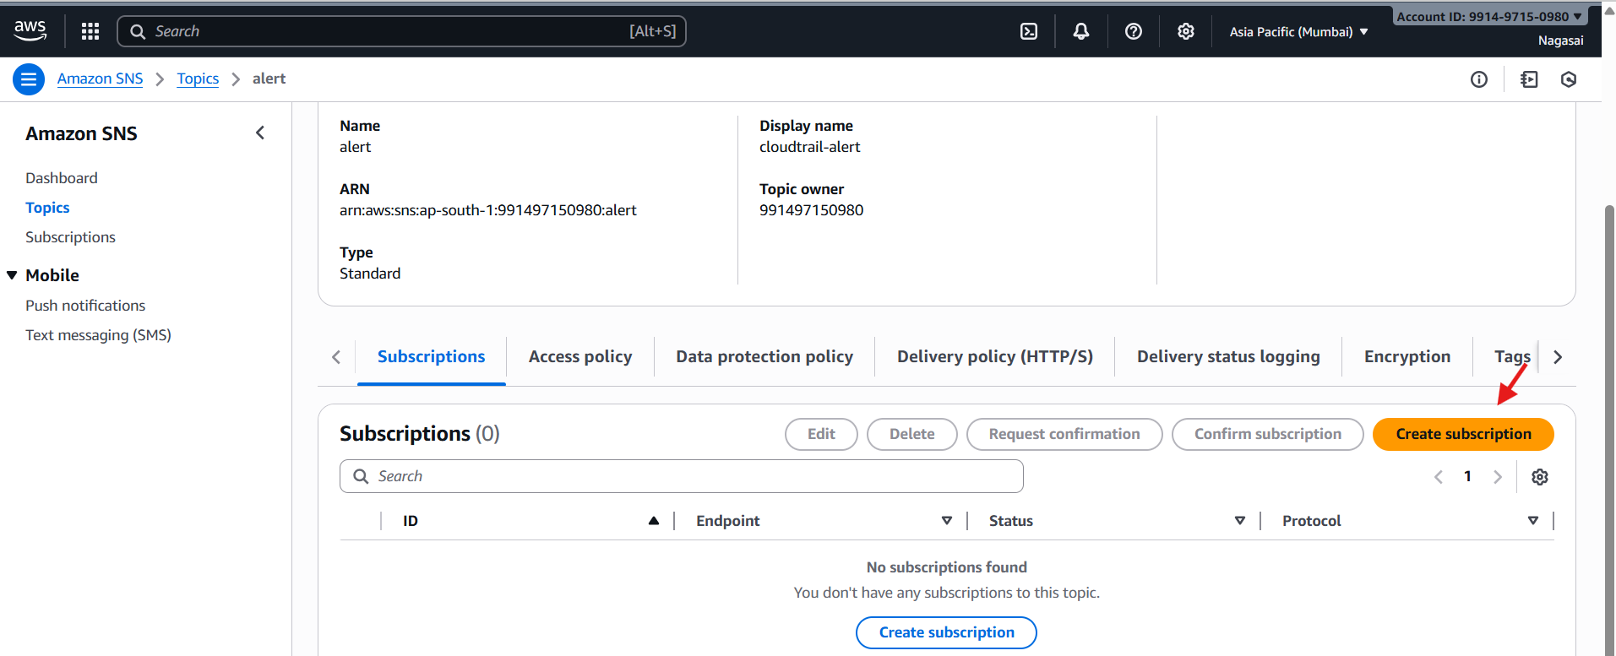
In subscription we have to give the protocol name(email or sms) and end point and click on create subscription.
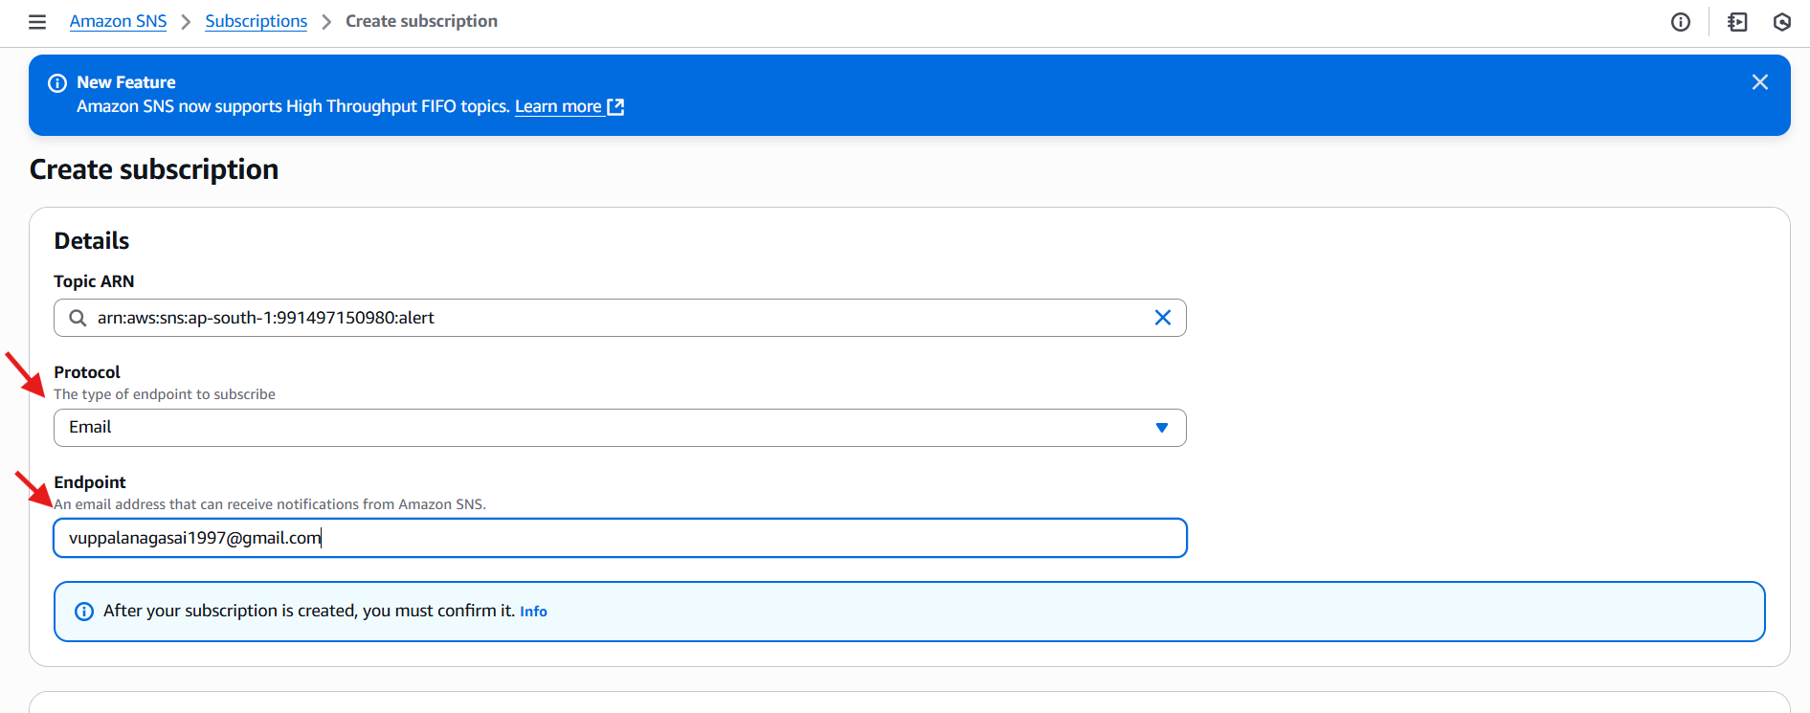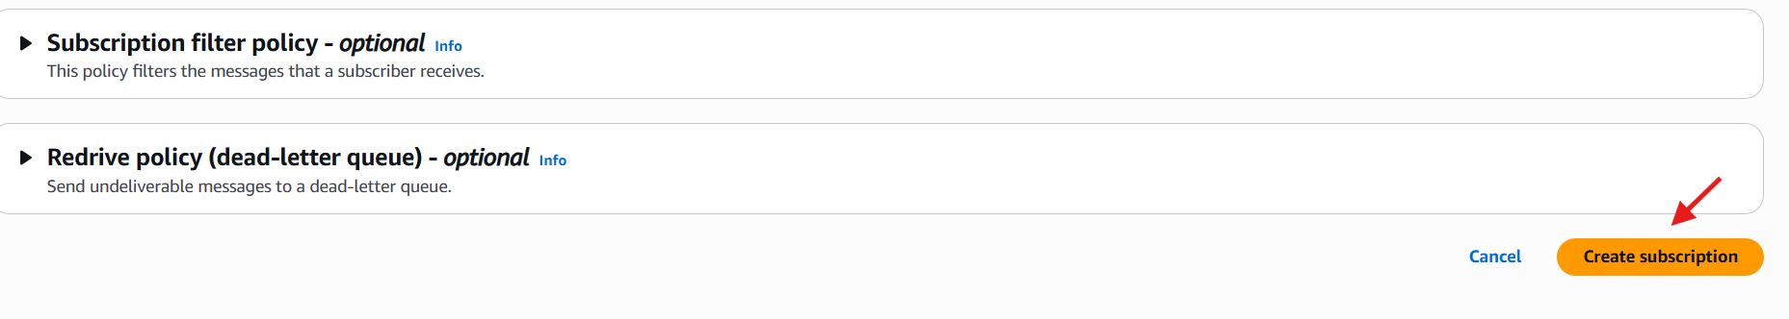
We Have received a email.
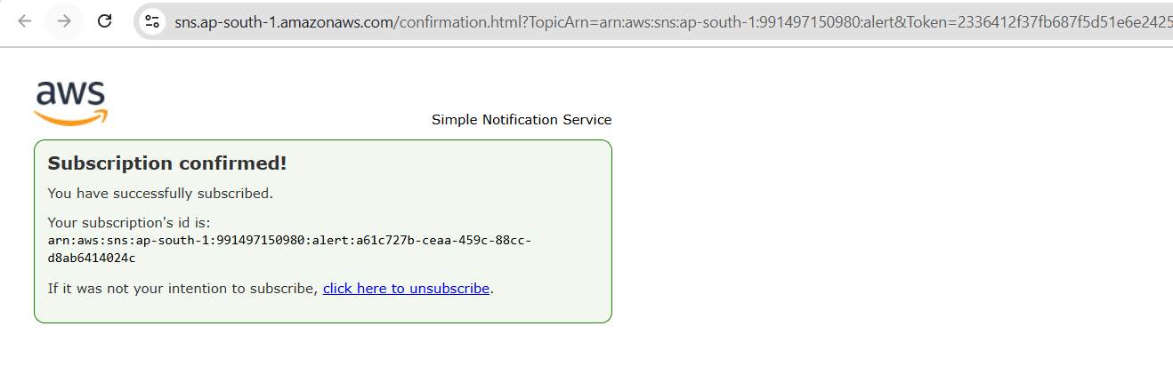
- Configure cloud watch monitoring and record the cpu utilization and other metrics of ec2.
Launch one ec2 instance
Go to cloud watchclick on create dashboard give the dashboard name and click on create dashboard.
Go to the dash board created add metric graphs and select ec2select the graph you want to monitor create widget type graph select and create the widget you can monitor cpu utilization.

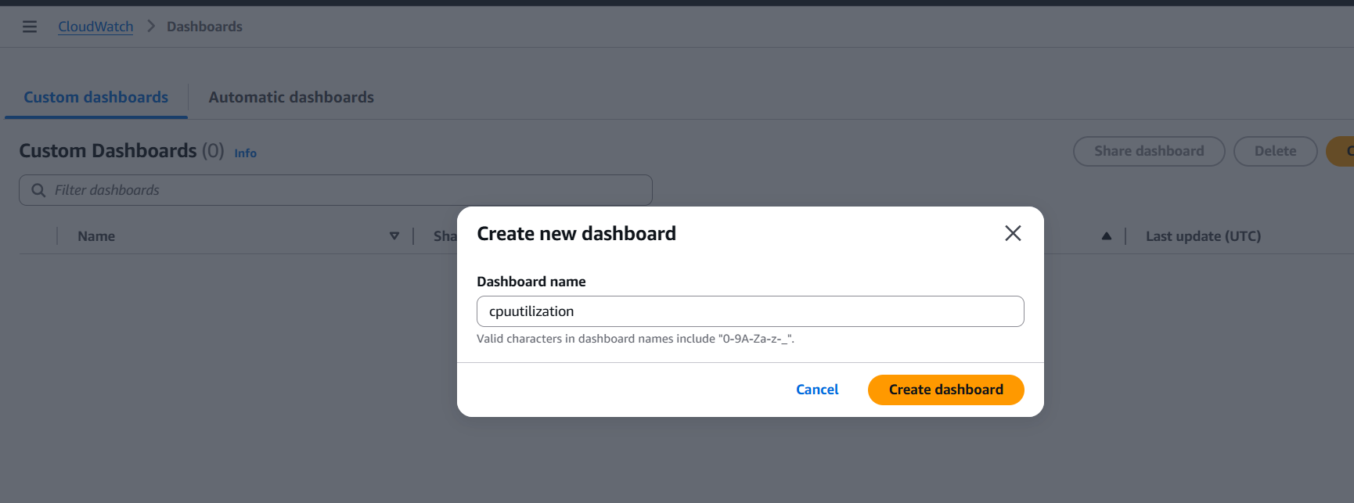
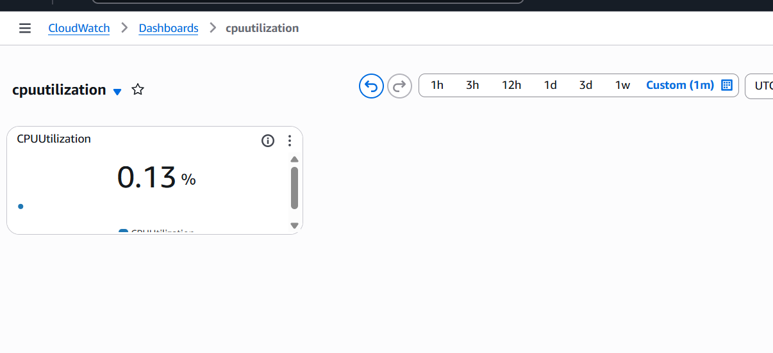
- Create one alarm to send alert to email if the cpu utilization is more than 70 percent.
Go to cloud watch create alarm.
Select the metricor search with instance idselect spu utilizationgive the parameter greater than 70 select the sns create alarm
•Now check the alarm and email will be sent to your mail id for the usage is more than the 70%

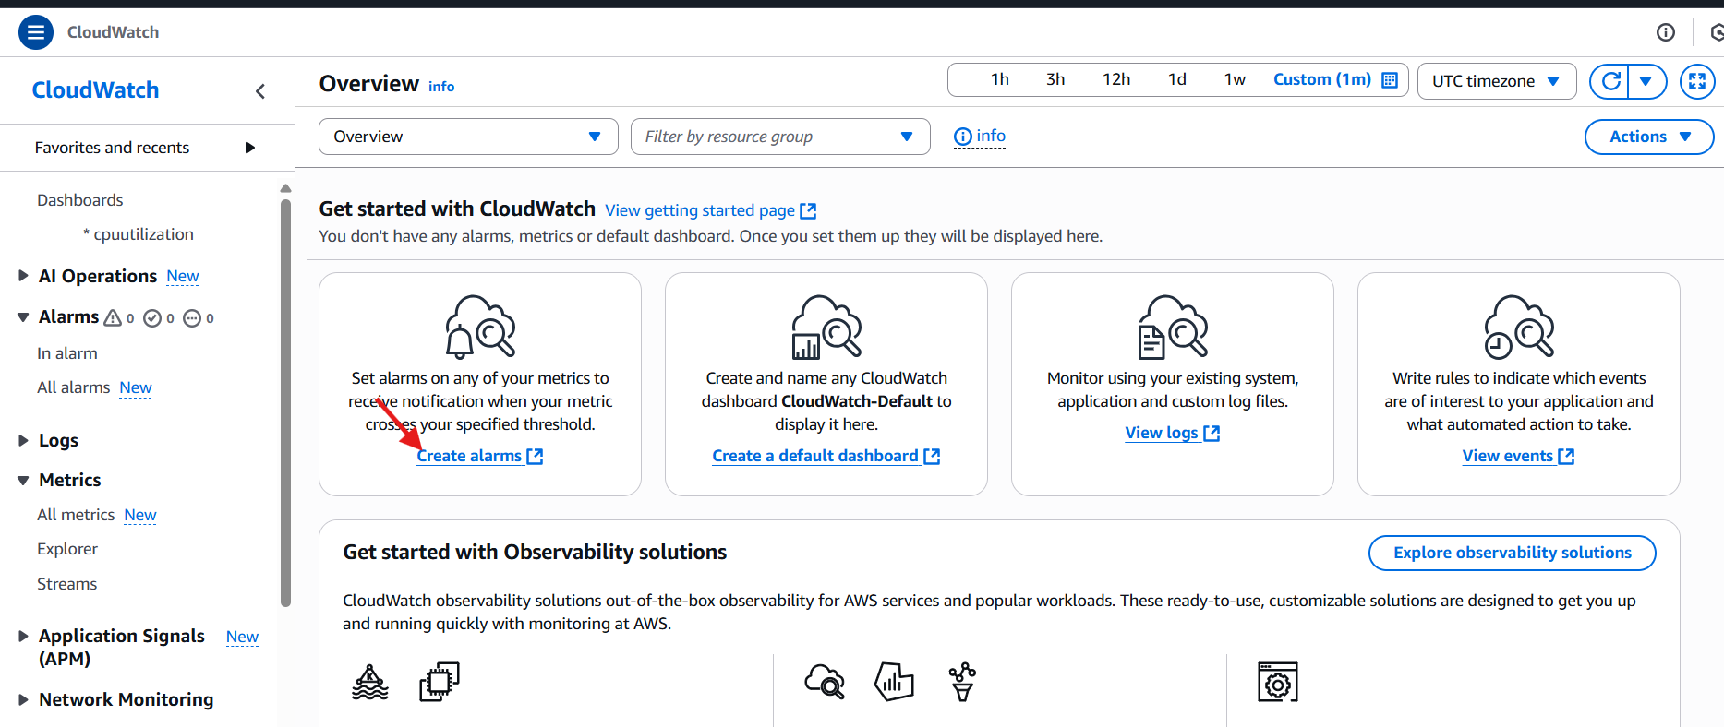
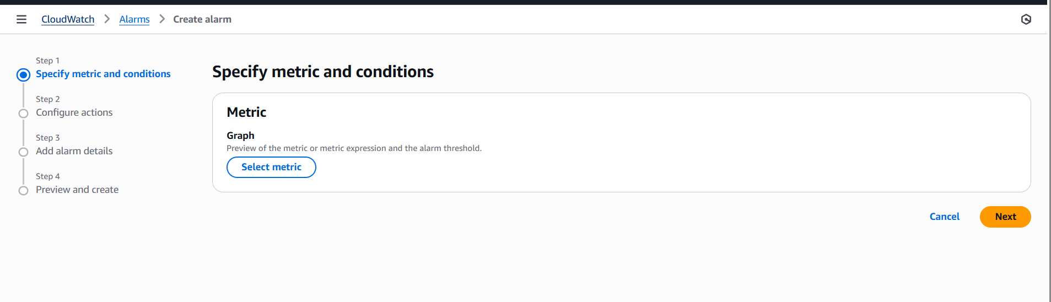
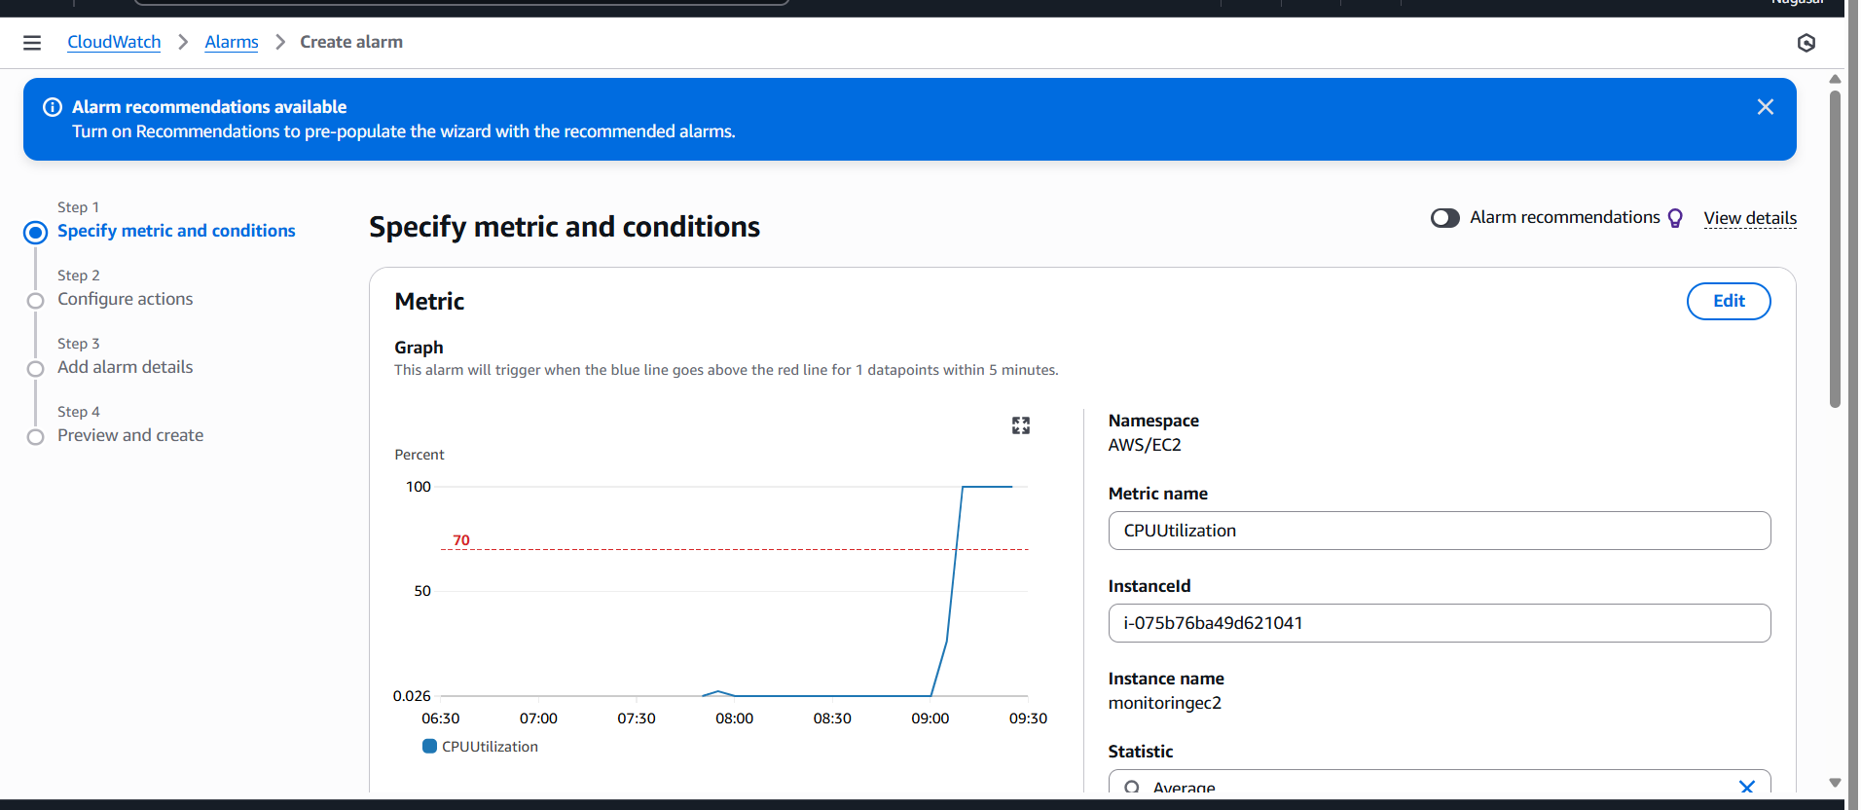
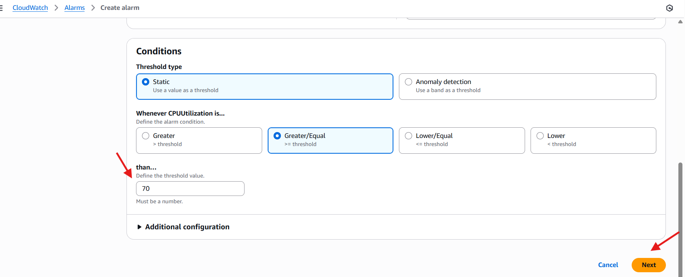
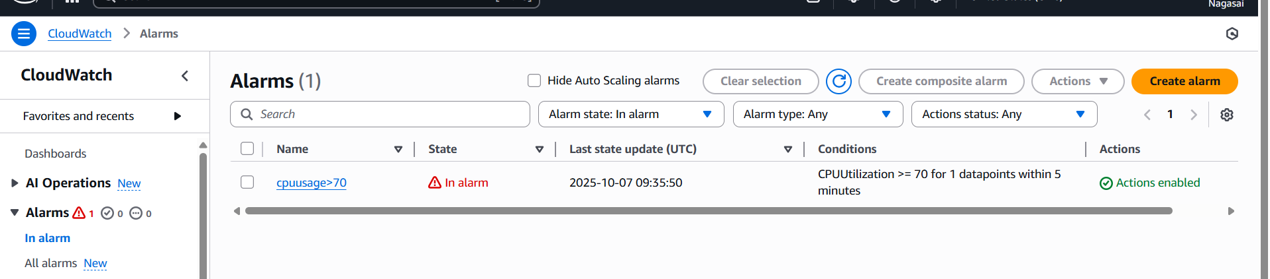
- Create Dashboard and monitor tomcat service wether it is running or not and send the alert.
Yum -y install java-1.8*
⦁ wget https://dlcdn.apache.org/tomcat/tomcat-9/v9.0.110/bin/a
pache-tomcat-9.0.110.tar.gz
⦁ vi /opt/monitoring.sh
⦁ paste these code here
--------------------------------------------------------------------------------------------
---
#!/bin/bash
# Check if Tomcat service is active
if systemctl is-active --quiet tomcat; then
STATUS=1
else
STATUS=0
fi
# Push custom metric to CloudWatch
aws cloudwatch put-metric-data \
--namespace "TomcatMonitoring" \
--metric-name "TomcatStatus" \
--value $STATUS \
--region eu-north-1
----------------------------------------------------------------------------------------------------
--
chmod 777 monitoring.sh
aws configure (paste your access id and secret key)
crontab -e
paste these in crontab editor (* * * * * /opt/monitoring.sh)
sh monitoring.sh
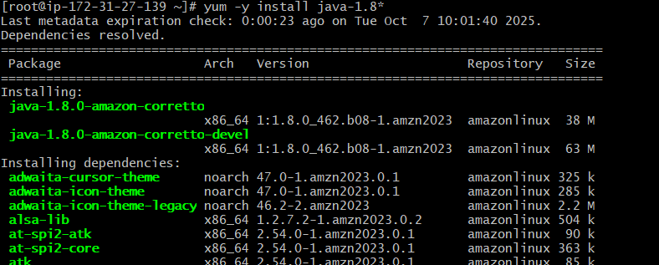
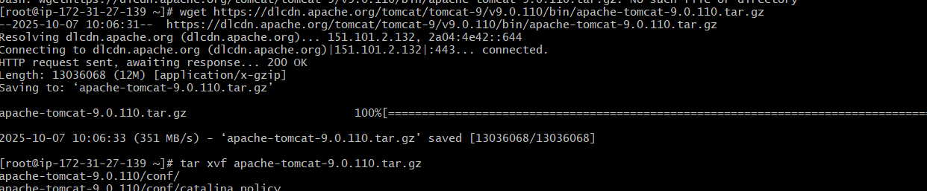
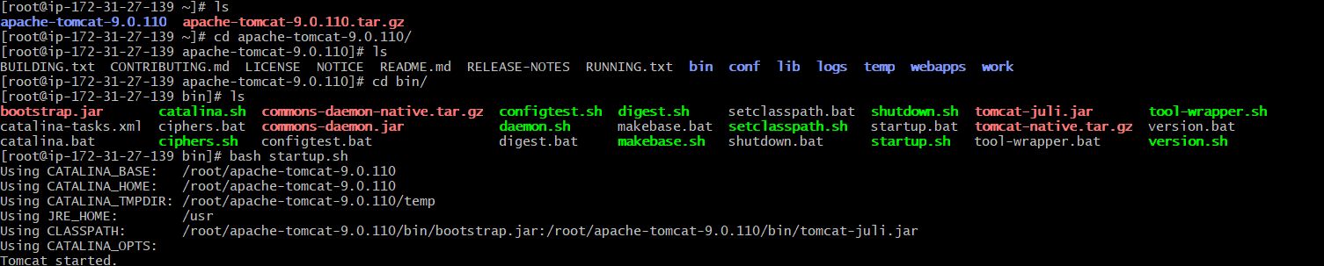
go to aws console and go to cloud watch
create a dashboard---select widget---number---select tomcat

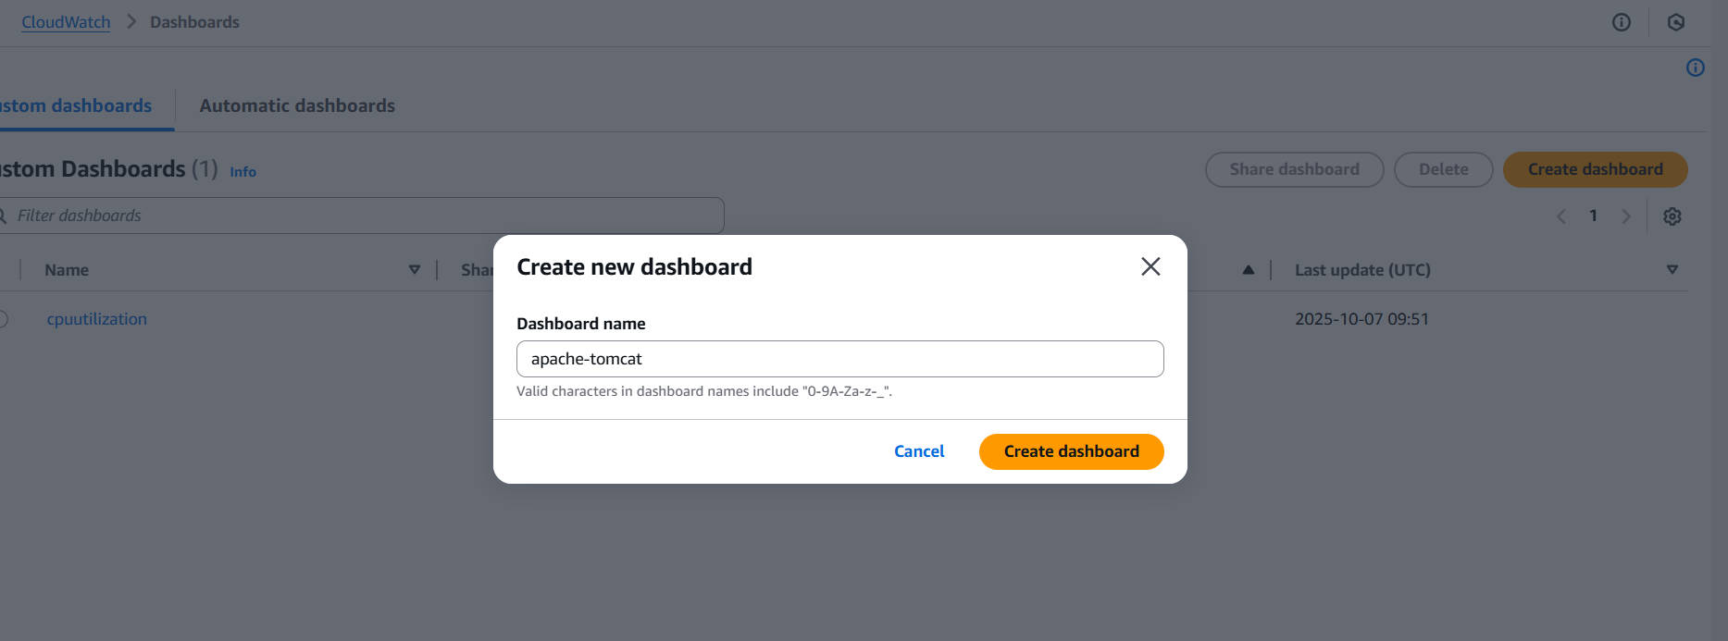
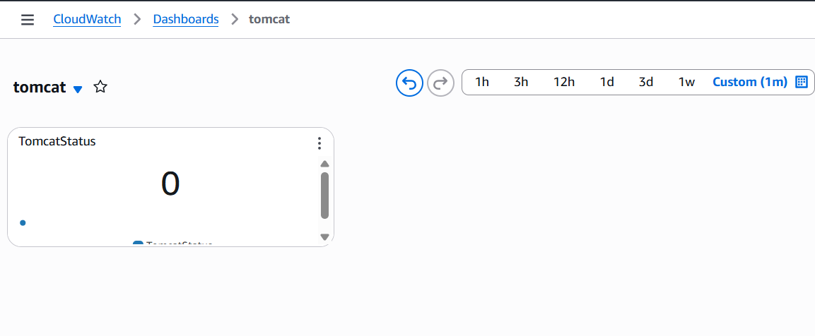

- Create Dashboard and monitor nginx service to send the alert if nginx is not running.
Create a intsanse in aws console
yum install nginx -y
systemctl start nginx
systemctl enable nginx
yum install cronie -y
systemctl start cronie
systemctl enable cronie
crontab -e
paste these code in cronie editor (* * * * * /home/ec2-
user/nginx-monitor.sh)
aws configure (paste your access id and secret key ) here
vi nginx-monitor.sh
---------------------------------------------------------------------------------------
---
#!/bin/bash
# Check if nginx service is active
if systemctl is-active --quiet nginx; then
STATUS=1
else
STATUS=0
fi
# Push custom metric to CloudWatch
aws cloudwatch put-metric-data \
--namespace "NginxMonitoring" \
--metric-name "NginxStatus" \
--value $STATUS \
--region us-east-2
--------------------------------------------------------------------------------------------------------------------
----
sh nginx-monitor.sh
go to console and cloud watch dashboard
add widget number
add nginx-monitor
create
it will show value 1 in monitoring chart when nginx is running or
else 0 when stopped
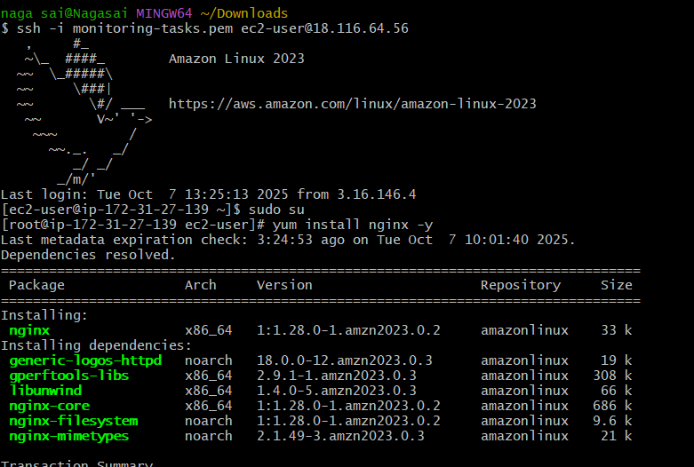
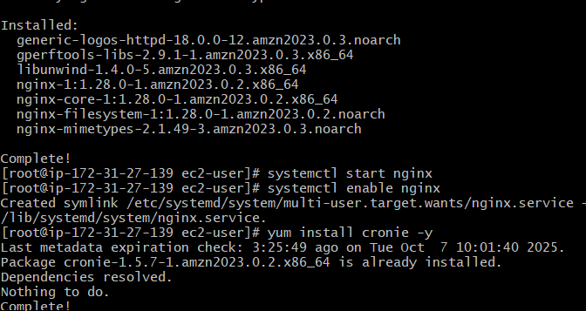
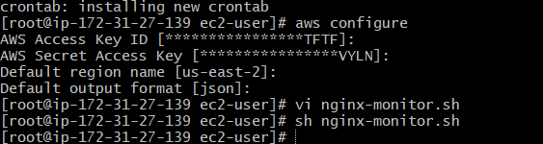

Go to CloudWatch →Alarms →Create alarm.
Choose metric →NginxMonitoring →NginxStatus
Condition: Whenever NginxStatus < 1 for 2 datapoints within 2
minutes

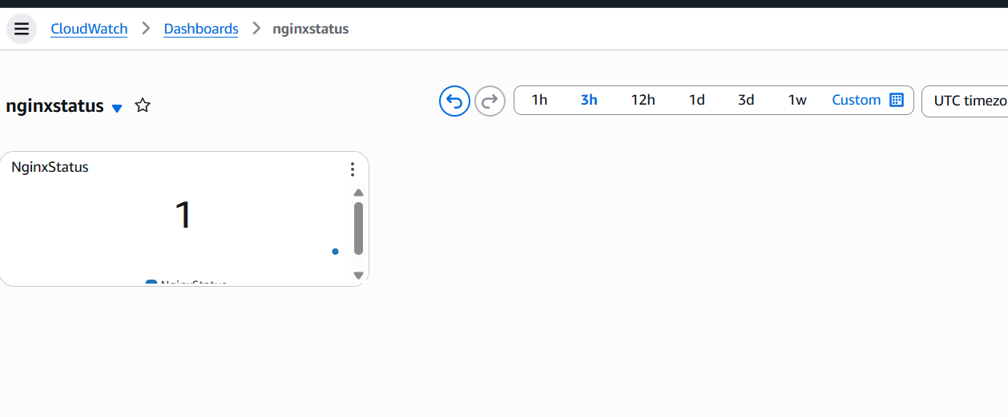
Next →Create SNS Topic (Nginx-Alerts)
Add your email
Confirm subscription from your inbox
Save alarm